**1. Write a function by passing degree as an argument and find out angle**

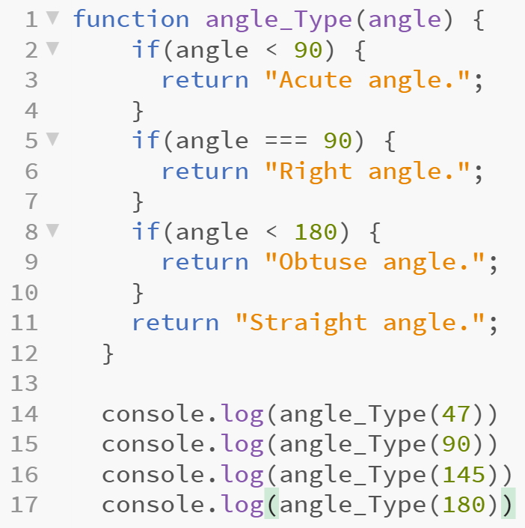

**2. To find area of triangle using Const**

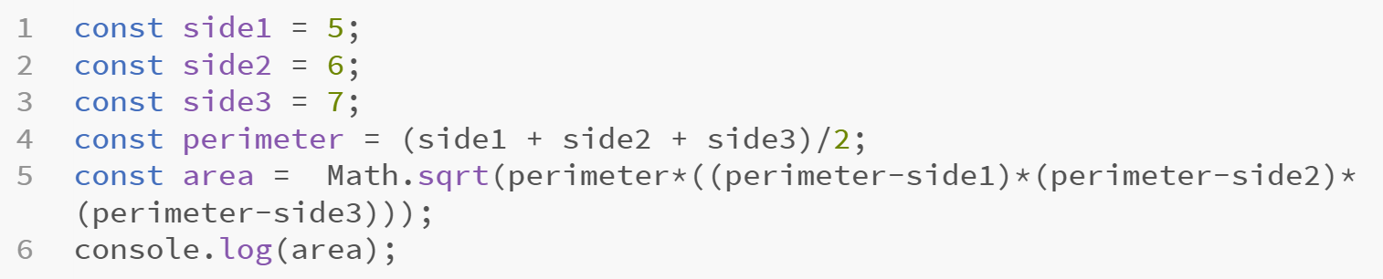

**3. Call divide() and multiply() functions to perform divide and multiplication operations**

**Form.html**

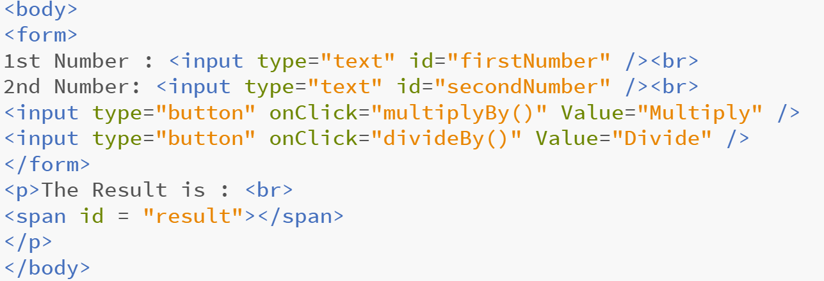

**Calculate.js**

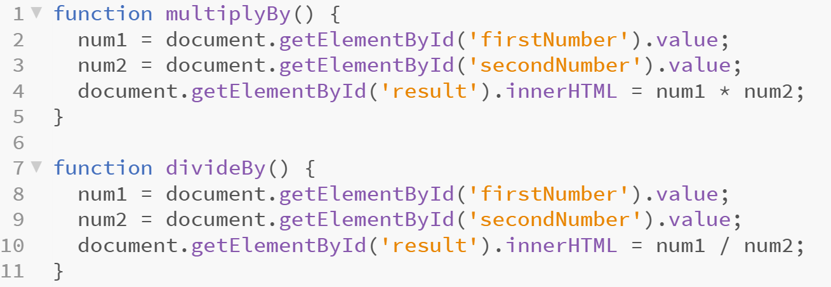

**4. Write a Function to split, sort and join.**

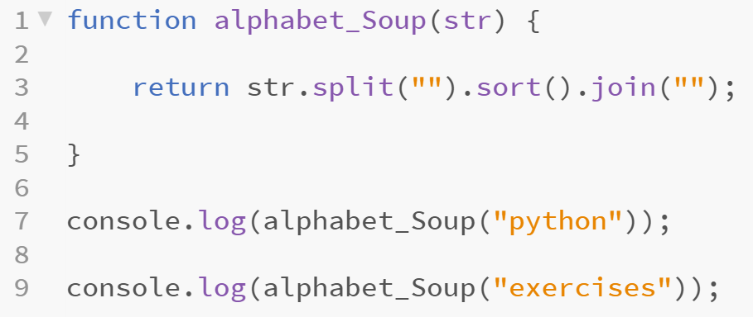

**5. Write a Function to print current page**

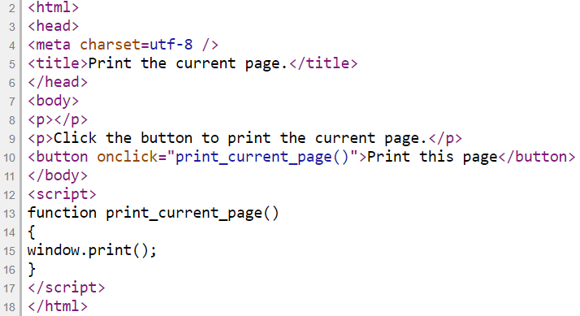

**6. Write a Function to replace a number in a string by ‘$’**

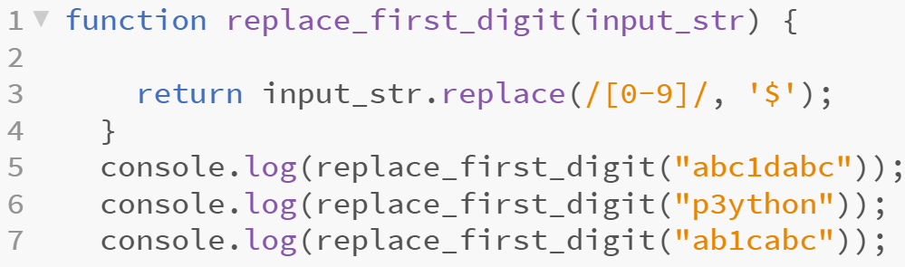

**7. To Display Current Time and Day.**

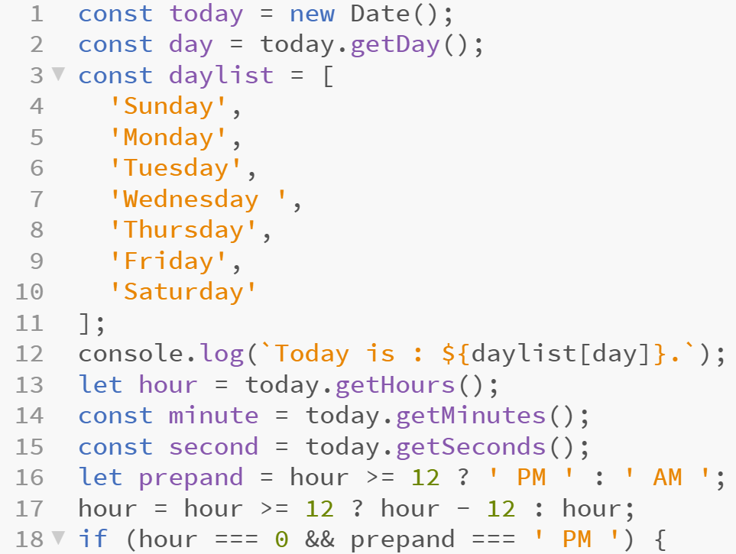

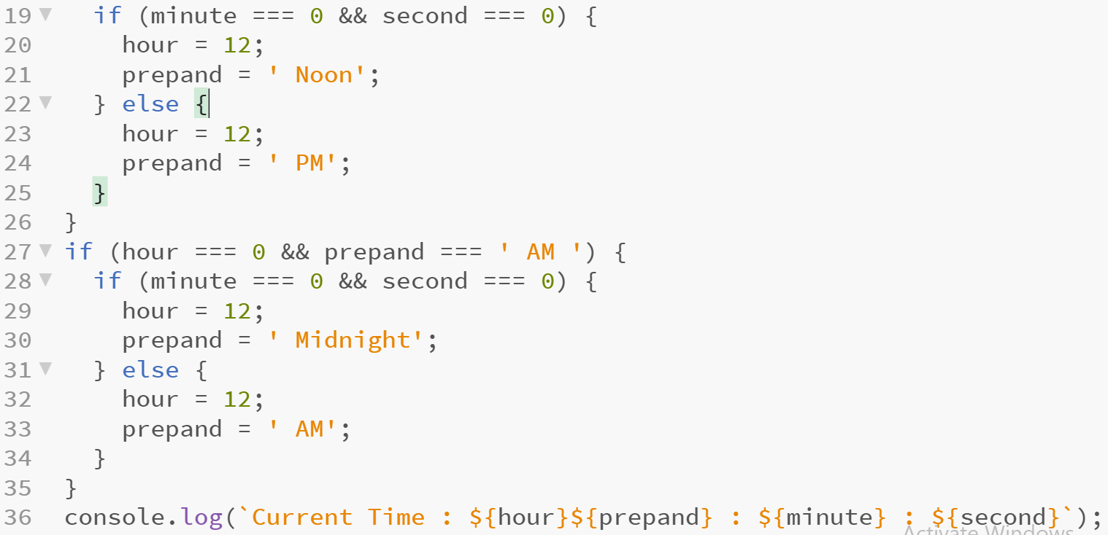

**//String Length**

**var txt = "ABCDEFGHIJKLMNOPQRSTUVWXYZ";**

**var sln = txt.length;**

**console.log(sln);**

**//The indexOf() method returns the index of (the position of) the first occurrence of a specified text in a string**

**var str = "Please locate where 'locate' occurs!";**

**var pos = str.indexOf("locate");**

**console.log(pos);**

**//The lastIndexOf() method returns the index of the last occurrence of a specified text in a string**

**var str = "Please locate where 'locate' occurs!";**

**var pos = str.lastIndexOf("locate");**

**//Returns -1 if not found**

**var str = "Please locate where 'locate' occurs!";**

**var pos = str.lastIndexOf("John");**

**console.log(pos);**

**//Both methods accept a second parameter as the starting position for the search**

**var str = "Please locate where 'locate' occurs!";**

**var pos = str.indexOf("locate", 15);**

**console.log(pos);**

**//The lastIndexOf() methods searches backwards (from the end to the beginning)**

**var str = "Please locate where 'locate' occurs!";**

**var pos = str.lastIndexOf("locate", 15);**

**console.log(pos);**

**//The search() method searches a string for a specified value and returns the position of the match**

**var str = "Please locate where 'locate' occurs!";**

**var pos = str.search("locate");**

**console.log(pos);**

**/*There are 3 methods for extracting a part of a string:**

**slice(start, end)**

**substring(start, end)**

**substr(start, length)**

**slice() extracts a part of a string and returns the extracted part in a new string. The method takes 2 parameters: the start position, and the end position (end not included).**

**This example slices out a portion of a string from position 7 to position 12 (13-1)*/**

**var str = "Apple, Banana, Kiwi";**

**var res = str.slice(7, 13);**

**console.log(res);**

**/*If a parameter is negative, the position is counted from the end of the string.This example slices out a portion of a string from position -12 to position -6*/**

**var str = "Apple, Banana, Kiwi";**

**var res = str.slice(-12, -6);**

**console.log(res);**

**//If you omit the second parameter, the method will slice out the rest of the string**

**var str = "Apple, Banana, Kiwi";**

**var res = str.slice(7);**

**console.log(res);**

**var res = str.slice(-12);**

**console.log(res);**

**/*substring() is similar to slice().**

**The difference is that substring() cannot accept negative indexes*/**

**var str = "Apple, Banana, Kiwi";**

**var res = str.substring(7, 13);**

**console.log(res);**

**/*substr() is similar to slice().**

**The difference is that the second parameter specifies the length of the extracted part*/**

**var str = "Apple, Banana, Kiwi";**

**var res = str.substr(7, 6);**

**console.log(res);**

**//If you omit the second parameter, substr() will slice out the rest of the string.**

**var str = "Apple, Banana, Kiwi";**

**var res = str.substr(7);**

**console.log(res);**

**//If the first parameter is negative, the position counts from the end of the string.**

**var str = "Apple, Banana, Kiwi";**

**var res = str.substr(-4);**

**console.log(res);**

**//The replace() method replaces a specified value with another value in a string**

**str = "Please visit Microsoft!";**

**var n = str.replace("Microsoft", "W3Schools");**

**console.log(n);**

**//By default, the replace() method replaces only the first match**

**str = "Please visit Microsoft and Microsoft!";**

**var n = str.replace("Microsoft", "W3Schools");**

**console.log(n);**

**//By default, the replace() method is case sensitive. Writing MICROSOFT (with upper-case) will not work**

**str = "Please visit Microsoft!";**

**var n = str.replace("MICROSOFT", "W3Schools");**

**console.log(n);**

**//To replace case insensitive, use a regular expression with an /i flag (insensitive)**

**str = "Please visit Microsoft! and MICROSOFT";**

**var n = str.replace(/MICROSOFT/i, "W3Schools");**

**console.log(n);**

**//To replace all matches, use a regular expression with a /g flag (global match):**

**str = "Please visit MICROSOFT and MICROSOFT";**

**var n = str.replace(/MICROSOFT/g, "W3Schools");**

**console.log(n);**

**//A string is converted to upper case with toUpperCase():**

**var text1 = "Hello World!"; // String**

**var text2 = text1.toUpperCase();**

**console.log(text2);**

**//A string is converted to lower case with toLowerCase()**

**var text1 = "Hello World!"; // String**

**var text2 = text1.toLowerCase();**

**console.log(text2);**

**//Joins Two Strings using concat()**

**var text1 = "Hello";**

**var text2 = "World";**

**var text3 = text1.concat(" ", text2);**

**console.log(text3);**

**//Concatenation using +**

**var text = "Hello" + " " + "World!";**

**console.log(text);**

**var text = "Hello".concat(" ", "World!");**

**console.log(text);**

**//The trim() method removes whitespace from both sides of a string:**

**var str = " Hello World! ";**

**alert(str.trim());**

**/*There are 3 methods for extracting string characters:**

**charAt(position)**

**charCodeAt(position)**

**Property access [ ]*/**

**//The charAt() method returns the character at a specified index (position) in a string**

**var str = "HELLO WORLD";**

**var m = str.charAt(0);**

**console.log(m);**

**/*The charCodeAt() method returns the unicode of the character at a specified index in a string:**

**The method returns a UTF-16 code (an integer between 0 and 65535)*/**

**var str = "HELLO WORLD";**

**var m = str.charCodeAt(0);**

**console.log(m);**